Practical 4
Task 1:

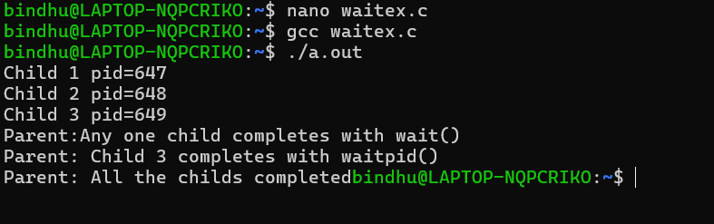

Task 2:

